public class Stack {
private Node top;
public Stack() {
top = null;
} // end default constructor

public boolean isEmpty() {
return top == null;
} // end isEmpty

public void push(Object newItem) {
top = new Node(newItem, top);
} // end push

public Object pop() throws StackException {
if (!isEmpty()) {
Node temp = top;
top = top.getNext();
return temp.getItem();
}
else {
throw new StackException("StackException on " + "pop: stack empty");
} // end if
} // end pop

public void popAll() {
top = null;
} // end popAll

public Object top() throws StackException {
if (!isEmpty()) {
return top.getItem();
}
else {
throw new StackException("StackException on " + "top: stack empty");
} // end if
} // end top

public Object clone() throws CloneNotSupportedException
{
Stack copy = new Stack();
Node curr = top, prev = null;
while (curr != null)
{
Node temp = new Node(curr.getItem());
if (prev == null)
copy.top = temp;
else
prev.setNext(temp);
prev = temp;
curr = curr.getNext();
}
return copy;
}
} // end Stack


Stack Exercises

1. Suppose an empty stack is provided and an input stream contains the numbers 1 2 3 4 5 6, in this order. The numbers are read one by one from the input stream and either go directly into the output stream or are pushed onto the stack. When all numbers from the input stream are processed, all the numbers from the stack are popped one by one and sent to the same output stream. Determine whether each of the following represent valid or invalid output streams.

(a) 1 2 3 4 5 6
(b) 1 2 3 6 5 4
(c) 2 4 6 5 3 1
(d) 4 5 6 3 2 1
(e) 3 2 1 4 5 6

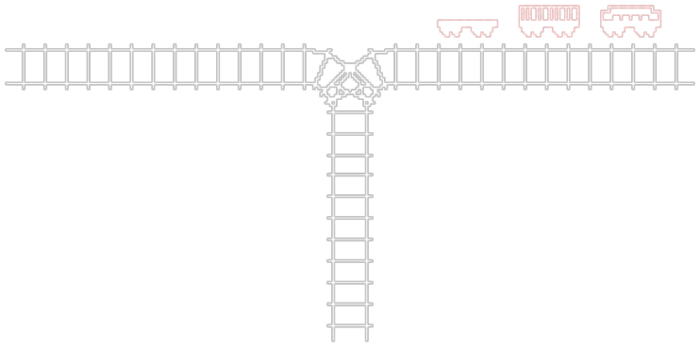
2.

Railroad cars numbered 1, 2, and 3 on the right track are to be permuted and moved along the left track. A car may be moved directly onto the left track, or it may be shunted onto the siding to be removed at a later time and placed on the left track. Find all possible combinations of cars that can be obtained on the left track by a sequence of these operations. For example, push 1, push 2, move 3, pop 2, pop1 arranges them in the order 3, 2, 1. Are any permutations not possible?
1.
(a) 1 2 3 4 5 6

(b) 1 2 3 6 5 4

(c) 2 4 6 5 3 1

(d) 4 5 6 3 2 1

(e) 3 2 1 4 5 6

2.

A Client Program for Running Our Stack Program...
(where our Object is of type Integer)

public class MyStack
{
public static void main(String[] args)
throws IOException, CloneNotSupportedException
{
Stack stack1 = new Stack();

processInput (stack1);
printStack (stack1);
}

private static void processInput(Stack s) throws IOException
{
InputStreamReader reader = new InputStreamReader(System.in);
StreamTokenizer tokens = new StreamTokenizer(reader);
int next = tokens.nextToken();
while (next != tokens.TT_EOF)
{
switch (next) {
case StreamTokenizer.TT_NUMBER:
Integer newVal = new Integer((int)tokens.nval);
s.push(newVal);
next = tokens.nextToken();
break;
default:
next = tokens.nextToken();
}
}
}

private static void printStack (Stack s) throws CloneNotSupportedException
{
Stack tempStack = (Stack) (s.clone());
int count = 0;

if (! tempStack.isEmpty())
System.out.println("*** Printing Out Stack: ");

while (! tempStack.isEmpty()) {
System.out.println(tempStack.top());
count++;
tempStack.pop();
}
System.out.println("\n*** You have a total of " + count +
" items in your stack.");
}
}

